7 March 2018

STAHL CraneSystems GmbH

Daimlerstraße 6

74653 Künzelsau

Your contact for questions on the content: Author:

Heike Metzger Daniela Peuckert

Tel. +49 7940 128-2388 VISUELL Studio für Kommunikation

Fax +49 7940 128-2300 Tel. +49 711 64868-0

[heike.metzger@stahlcranes.com](mailto:heike.metzger@stahlcranes.com) daniela.peuckert@visuell.de

[www.stahlcranes.com](http://www.stahlcranes.com)

Weightlifting on the Nile

Technology from STAHL CraneSystems stands the test in the Egyptian heat.

**Up to 140 tonnes heavy and up to 40 metres long: the prefabricated concrete parts made by the Egyptian manufacturers ECPC Company are real heavyweights. On top of this come heat and dust – none of which are a problem for the proven technology from STAHL CraneSystems, which does not even work up a sweat in the face of such extreme conditions.**

The population of Egypt has been growing for decades – by about two million people a year. One of the many challenges this fast population growth poses for the state is overcoming the growing volume of traffic. Although more and more people are using the subsidised railways and metro as means of transport, traffic on the roads is also rising: the number of private cars increased from 2.2 to 3.5 million from 2008 to 2013. On top of this, a large part of freight is transported by road. Egypt is therefore investing heavily in infrastructure projects such as countrywide expansion of roads, bridges and railway lines as well as the metro lines in Cairo and the Nile and Suez Canal waterways.

Prefabricated concrete parts are often used to construct the roads and railways. These parts are produced in a precast factory and transported to their destinations once hardened. ECPC Company is one of the leading manufacturers of prefabricated concrete parts in Egypt and is located in Madinat al-Aschir min Ramadan, a town 46 km north-east of Cairo. It manufactures concrete parts for road and tunnel construction as well as concrete pipes for drinking water supply and sewage systems. To serve the growing demands of the Egyptian market, ECPC decided to expand its factory by a new depot with two portal cranes. The contract was awarded to the company ICF International Crane Factory, a certified partner of STAHL CraneSystems, against competition from a French competitor.

The engineers and technicians of International Crane Factory began planning the installation in March 2017. The hoists and components were manufactured in the STAHL CraneSystems factory in Künzelsau and dispatched on their long journey to Egypt in June 2017. International Crane Factory and STAHL CraneSystems maintained close contact the whole time. International Crane Factory already installed two double girder portal cranes with a span of 32 metres and lifting capacity of 70 tonnes each in July 2017. Each crane is equipped with an AS 7 wire rope hoist in twin implementation with double rail crab. As the ropes of the twin hoist run in opposite directions simultaneously, the concrete parts are lifted and lowered without any sideways movement of the hook and can be positioned exactly. To handle the prefabricated parts, which can weigh up to 140 tonnes each and reach lengths of up to 40 metres, the two portal cranes can be operated individually or synchronously. The cranes are driven precisely with a total of 32 SR wheel blocks and eight frequency-controlled travel drives. Thanks to the prepared connections, the wheel blocks can be mounted quickly and simply with a head connection.

The reliable technology of STAHL CraneSystems is just the right thing whenever the going gets tough – such as in the hot and dusty environment of Egypt. All components are designed for ambient temperatures up to +45 °C and withstand the harsh conditions effortlessly. Using the standardised, tried-and-tested components from STAHL CraneSystems as basis, it was possible to find a high-performance and maintenance-friendly solution fulfilling all customer requirements optimally. ECPC Company and International Crane Factory are already planning further projects together, for example installation of a new portal crane with a lifting capacity of 6,300 kg.

*3,970 characters (incl. blanks)*

Photos:

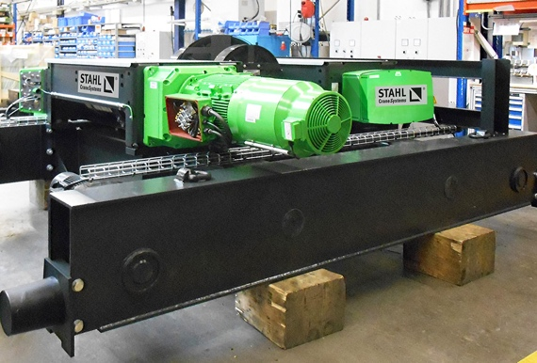

The AS 7s are manufactured in twin implementation in the STAHL CraneSystems factory in Künzelsau.

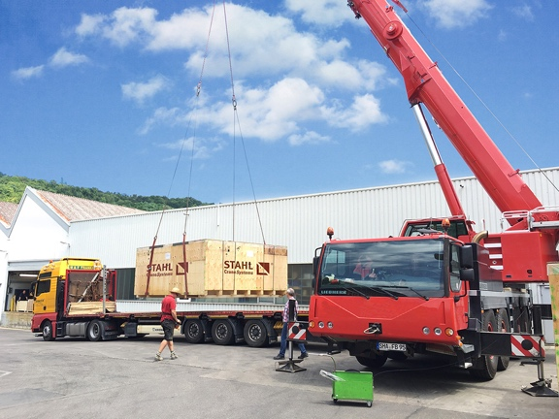In June 2017 the hoists and components start their journey from Germany to Egypt.

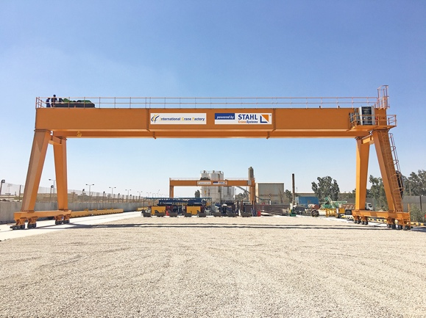The two AS 7 twin hoists lift concrete parts weighing up to 140 tonnes.

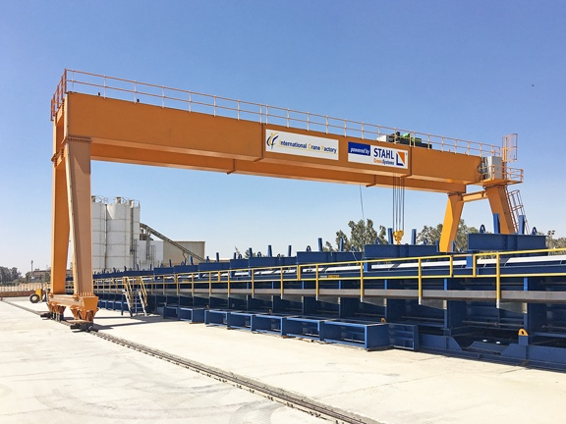ECPC Company is one of the largest manufacturers of precast concrete parts in Egypt.

|  |  |
| --- | --- |
|  |  |

ECPC Company is one of the largest manufacturers of precast concrete parts in Egypt.

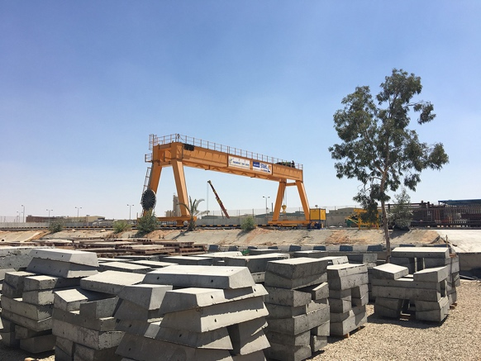

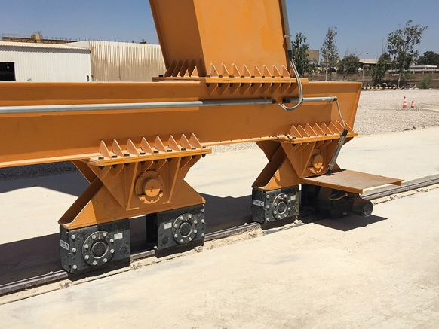

The two portal cranes run on a total of 32 wheel blocks. Eight frequency-controlled travel drives are used for this.

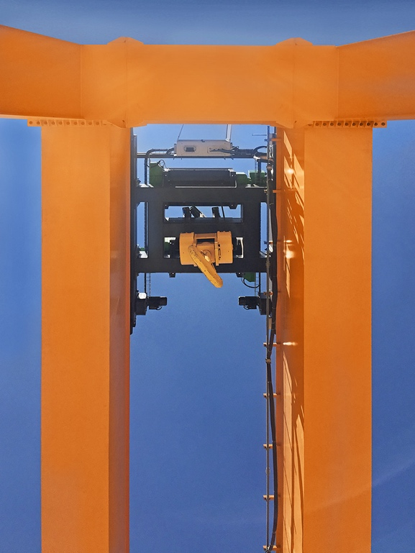

As the ropes of the twin hoist run in opposite directions simultaneously, the load is lifted and lowered without any sideways movement of the hook and can be positioned exactly.

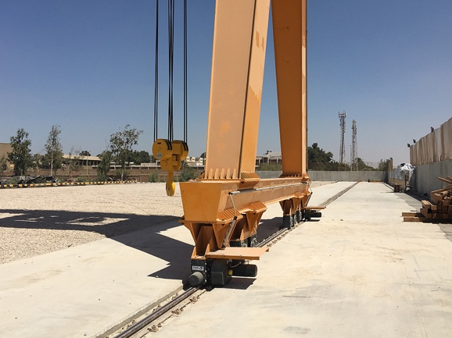The two portal cranes run on a total of 32 wheel blocks. Eight frequency-controlled travel drives are used for this.

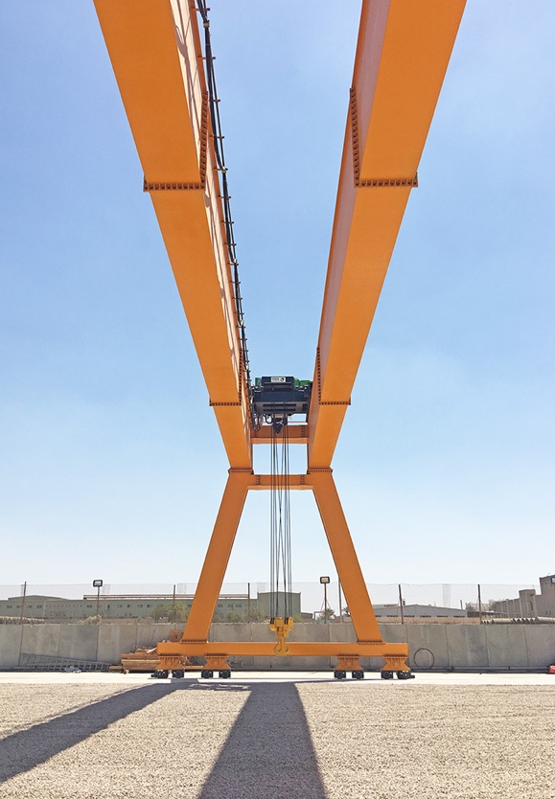

As the ropes of the twin hoist run in opposite directions simultaneously, the load is lifted and lowered without any sideways movement of the hook and can be positioned exactly.