8 August 2018

STAHL CraneSystems GmbH

Daimlerstraße 6

74653 Künzelsau

Your contact for questions on the content: Author:

Heike Metzger Daniela Peuckert

Tel. +49 7940 128-2388 VISUELL Studio für Kommunikation

Fax +49 7940 128-2300 Tel. +49 711 64868-0

[heike.metzger@stahlcranes.com](mailto:heike.metzger@stahlcranes.com) daniela.peuckert@visuell.de

[www.stahlcranes.com](http://www.stahlcranes.com)

Mission underground

Wire rope hoists from STAHL CraneSystems deployed in tunnelling project in Austria

**The company ACIMEX, at home in the heart of the Loire Valley in France, has offered bespoke solutions in the heavy-duty hoisting sector for 45 years. It specialises in the transportation of objects weighing several tons using air vacuum technology or hydraulic and mechanical grabs. STAHL CraneSystems has regularly equipped these special solutions with durable and high-quality technology since the company’s inception. Working closely together, the engineers of the two companies build machines that are used around the world in the construction, metallurgy, aviation and energy industries.**

Tunnelling requires strong and reliable machinery to ensure safe construction of the tubes. To this end, ACIMEX manufactures segment trolleys and segment erectors that handle the individual precast elements at the tunnel construction site: the segment trolley, fitted with a vacuum lifter, grips and lifts the segments from the service train and transports them deeper inside the tunnel. There they are picked up by segment erectors with the help of an air vacuum and placed in their final position. Fitted with two lateral rubber suction cups fastened underneath the chassis and a central vacuum pump, the ACIMEX segment erector can turn the elements in X, Y and Z-direction by up to 360°. Parts weighing up to 20 tonnes are lifted in this way to the highest possible position and placed with a precision of ± 5°. The hoisting technology that performs this work often comes from STAHL CraneSystems.

In Semmering, Austria, a 27.3 kilometre long railway tunnel between Gloggnitz in Lower Austria and Mürzzuschlag in Styria is set to pass under the northern Alps as from 2026. For the machines in use here, ACIMEX ordered three identically constructed wire rope hoists from STAHL CraneSystems to adjust the precast elements picked up by the segment erectors exactly. The SHF 5020-40 wire rope hoists with 1/1 reeving and a length of 2 were manufactured in the company’s Künzelsau plant. For this application, the customer required an above-average lifting speed, which was achieved by using a hoist controller with frequency inverter and motor encoder for closed-loop control. The closed-loop control, combined with software, makes it possible to compare the actual speed of the hoist with the set speed and to adjust it if necessary. In this way lifting speeds of 7 to 12 metres per minute can be achieved. The frequency inverter further enables smooth acceleration and deceleration movements during the lifting process.

STAHL CraneSystems delivered the hoists to ACIMEX in April 2017. The successful and timely completion of the machines once again illustrates the fruitful collaboration between the two companies.

*2,806 characters*

**Photos:**

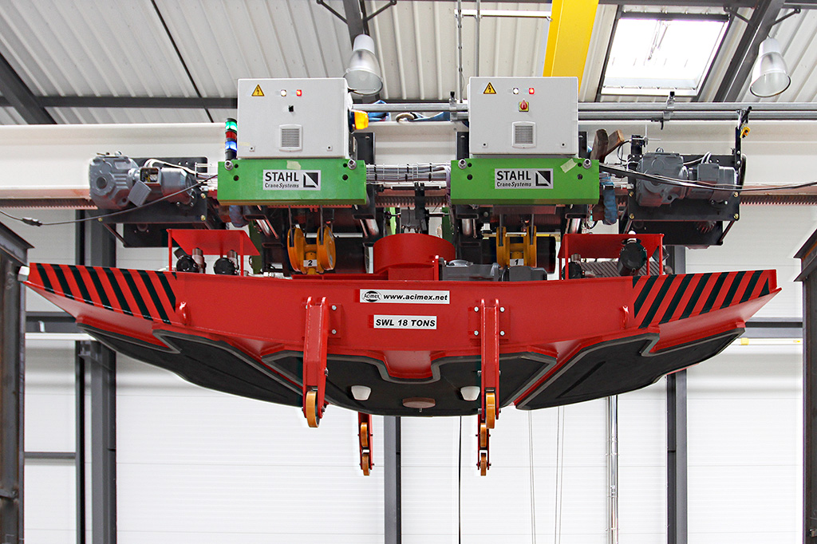The ACIMEX segment erector equipped with SHF wire rope hoists from STAHL CraneSystems

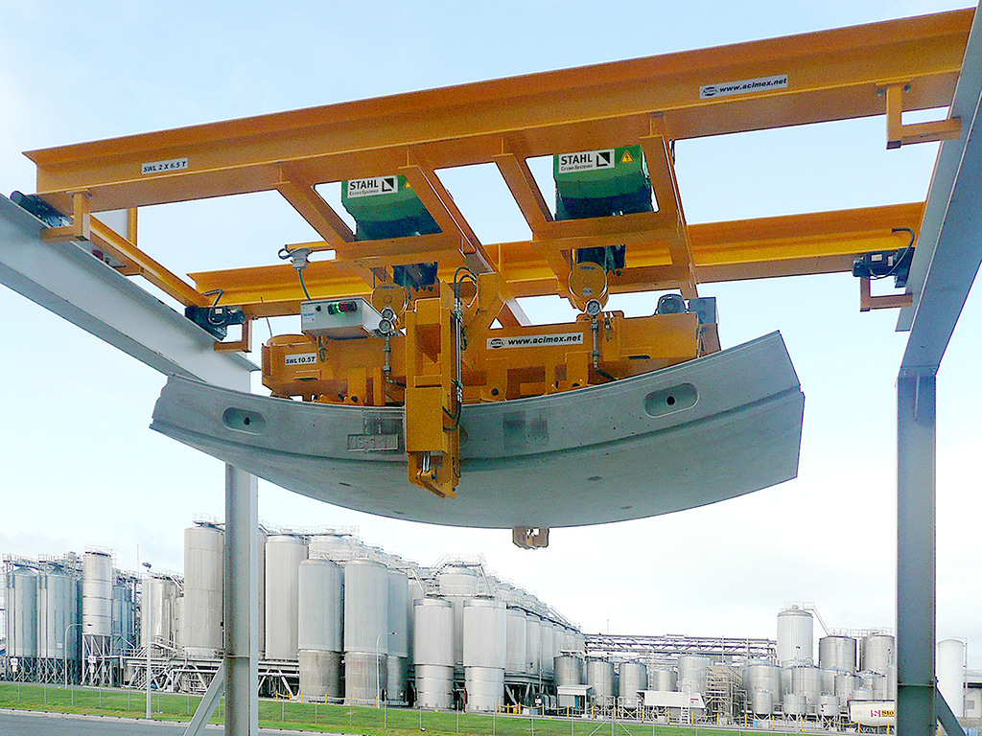On the job: the heavy precast elements are lifted by way of air vacuums

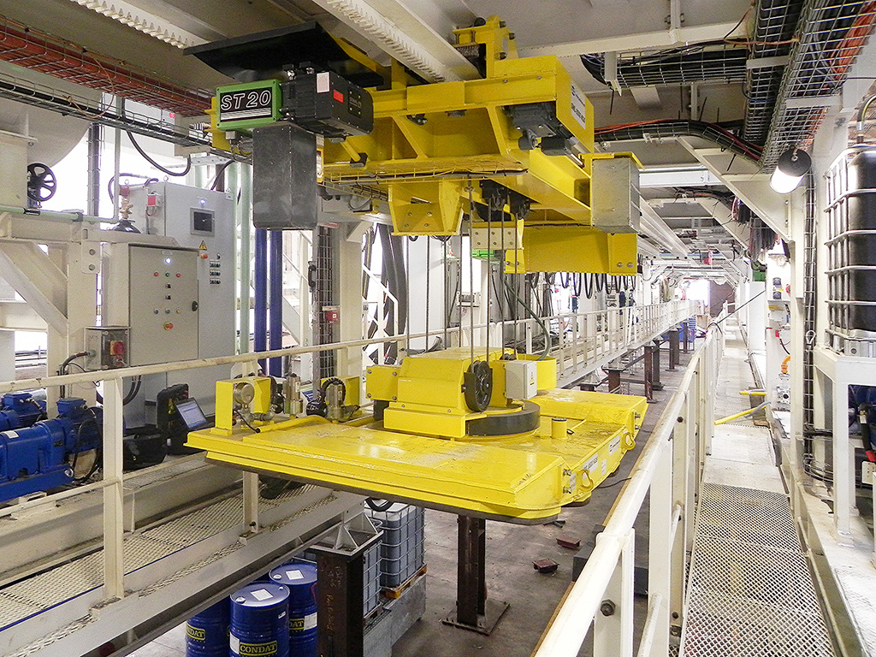All machines are manufactured and tested in the ACIMEX plant in the French town of Saint-Avertin

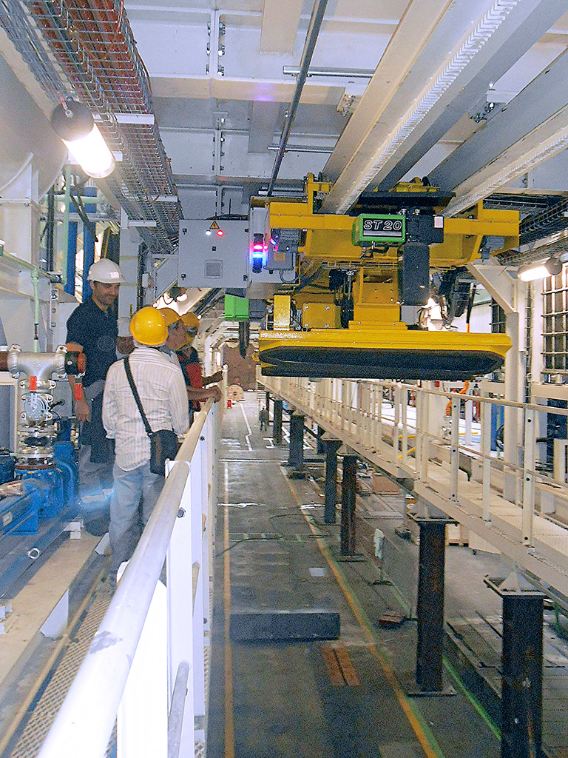

Strict controls and regular   
 further developments ensure the   
 high quality of the products of   
 ACIMEX and STAHL CraneSystems